School: Computer Science
Institution: University of Windsor
Term: Fall 2018
Course: 03-60-315-1 : Database Management Systems
Instructor: Dr. C. I. Ezeife
Assignment #2: Total: 50 marks
Handed Out:Thurs. Sep. 27, 2018; Due Thurs Oct. 18, 2018

Objective of Assignment: To test on knowledge and design of relational model constraints, relational database schemas, functional dependencies and normalization of relational databases.
Scope: Assignment covers materials from Chapters 5 and 14 of book discussed in class.
Electronic Assignment Submission: Done through http://blackboard.uwindsor.ca
Marking Sheme : The mark for each of the questions is indicated beside each question.
Academic Integrity Statement: Remember to submit only work that is yours and include the following confidentiality agreement and statement at the beginning of your assignment.

CONFIDENTIALITY AGREEMENT & STATEMENT OF HONESTY
I confirm that I will keep the content of this assignment/examination confidential.
I confirm that I have not received any unauthorized assistance in preparing for or doing this assignment/examination. I confirm knowing that a mark of 0 may be assigned for copied work.
________________________________________ ________________________________________
Student Signature Student Name (please print)
________________________________________ ________________________________________
Student I.D. Number Date

Marking Scheme : The mark for each question and sub question is shown with the question below. Place your solutions in tables where possible.

For office Use only
Question | Mark
1 | /20
2 | /10
3 | /10
4 | /10
Total | /50

CHAPTER 5: THE RELATIONAL DATA MODEL AND RELATIONAL DATABASE CONSTRAINTS

- (total marks 20) Given the same simple SalesRep-Worksin-SalesArea database schema you worked on in assignment 1, which contains three files described as follows:
SalesRep (SRid: integer, SRname: string, SRage: integer, salary: real)
Worksin (SRid: integer, Arid: integer, hours: integer)
SalesArea (Arid: integer, Aname: string, city: string, budget: real, managerid: integer)
Note : SRid, SRname, SRage, salary are the sales rep id, name, age and salary respectively. Also, hours is the number of hours worked by sales rep in the sales area. The rest of the attributes Arid, Aname, city, budget and managerid are the area id, name, location, budget and managerid respectively. A manager is a sales rep.

Assume that an update is to be made to this database to enter information about a new Salesrep who is now the new manager of an existing SalesArea (replacing the old manager) and although he is new, he has worked some hours in another existing SalesArea. Answer the following questions on what specific relations, attributes and operations (eg. insert, modify, delete) that need to be done for this update to be implemented.

Provide your answers both in descriptive sentence and using the formal database operations of INSERT, MODIFY, DELETE with specific attributes and relations when possible.

(a) Give the set of needed insert, modify or delete operations for this update. 5 marks
(b) What types of constraints (explain with data) would you expect to check for this update to be done? 5 marks
(c) Which of these constraints are key, entity integrity, and referential integrity constraints and which are not? 5 marks
(d) Specify all the referential integrity (foreign key) constraints on this database. 5 marks
(Total for que 1 is 20 marks)

Solution:
Question | Answers
a. Give the operations for this update.  5 marks | Since the subject is an existing SalesRep, we do not need to add him to the SalesRep relationship.  Let X denote the existing Arid which is getting the new manager.  Let Y denote the new SalesRep's SalesRepID  Since the area exists in our record, we can just update it.  MODIFY SalesArea  SET managerID = Y  WHERE Arid = X  The attribute of SRid working in the area then needs to be updated.  MODIFY Worksin  SET SRid = Y  WHERE Arid = X
b. What types of constraints would you expect to check?  5 marks | -check if SalesRep salary is lower than the SalesArea budget  -when updating SalesArea, check if managerid is an existing SRid of SalesRep  -when updating Worksin, check if SRid is an existing SRid of SalesRep  -Check if the new Worksin key (Y, X) is unique in the Worksin entity set  -check that SRid of Worksin is not null  -check that managerID of SalesArea is not null
c. Which of these constraints are key, entity integrity, and referential integrity constraints and which are not?  5 marks | Key constraints:  -Check if the new Worksin key (Y, X) is unique in the Worksin entity set  Entity integrity constraints:  -check that SRid of Worksin is not null  -check that managerID of SalesArea is not null  Referential integrity constraints:  -managerid of SalesArea must be an existing SRid of SalesRep  -SRid of Worksin must be an existing SRid of SalesRep  The rest of the constraints are not key, entity integrity, or referential constraints.
d. Specify all the referential integrity constraints on this database.  5 marks | -managerid of SalesArea must be an existing SRid of SalesRep  -SRid of Worksin must be an existing SRid of SalesRep  -Arid of Worksin must be an existing Arid of SalesArea

- (total marks 10) Using your own SalesRep-Worksin-SalesArea database instance from assignment 1, login to the SQL query processor on our cs server, called Oracle Sqlplus to create the three database table and insert the tuples in your database state with the following sequence of instructions. Note that this exercise is to get you beginning to connect to SQLplus while preparing to learn full SQL language syntax in Chapters 6 and 7. You will be given the instructions to use now. Show the result of this exercise through a script file you will attach.
(Total for que 2 is 10 marks)
i. First connect to our cs.uwindsor.ca through either SSH client or NoMachine
ii. Then create a script file to capture your Unix session and connect to Sqlplus with:
>script username_assn2que2
>sqlplus <username>
>password
sqlplus> CREATE TABLE SalesRep
(SRid NUMBER(4) NOT NULL,
SRname VARCHAR2(15),
SRage NUMBER(2),
Salary NUMBER(8, 2),
PRIMARY KEY(SRid));

Sqlplus> CREATE TABLE SalesArea
(Arid NUMBER(4) NOT NULL,
Aname VARCHAR2(15),
budget NUMBER(10,2),
managerid NUMBER(4),
PRIMARY KEY(did),
FOREIGN KEY (managerid) REFERENCES SalesRep (SRid));

Sqlplus> CREATE TABLE WORKSIN
(SRid NUMBER(4) NOT NULL,
Arid NUMBER(4) NOT NULL,
Hours NUMBER(3,1) ,
PRIMARY KEY(SRid, Arid),
FOREIGN KEY (SRid) REFERENCES SalesRep (SRid),
FOREIGN KEY (SRid) REFERENCES SalesArea(Arid));

Sqlplus> INSERT INTO SalesArea
VALUES (1111, ‘John Smith’, 22, 20000.60);
Sqlplus> COMMIT;
// Repeat similar INSERT instructions for all the data in your tables
// starting with the entity tables first, eg, SalesRep, SalesArea, before WORKSIN.

Sqlplus> select * from cat; // to show all the objects in your catalogue
Sqlplus> select * from SalesRep; // to show the contents of this table
sqlplus> exit //to exit sqlplus

exit // to exit and create script file

Solution: (10 marks)
An attached script showing execution of CREATE TABLE instructions and INSERT INTO table instructions with the few SELECT instructions to show contents of the catalogue and tables.

CHAPTER 14: Database Design Theory: Introduction to Normalization Using Functional and Multivalued Dependencies
3. (total marks 10) Consider the following relation:
Enrolled(Studid, Crsid, SName, Score, Lettergrade)
Assume that a student (Studid) may be enrolled in multiple courses (Crsid) and hence {Studid, Crsid } is the primary key.
Thus, the following functional dependency exists:
{Studid, Crsid } -> {SName, Score, Lettergrade}
Additional dependencies are:
Studid -> SName
Score -> Lettergrade

Based on the given primary key,
- is this relation in 1NF, 2NF, or 3NF? Why or why not?
- If not in 2NF at least, normalize it completely into 2NF and 3NF? Provide your answers using functional dependencies (FDs). (Total for que 3 is 10 marks)
Solution (i): (5 marks)
Answer:

The relation is in 1NF because it does not contain any multivalued or composite attributes. It is not in 2NF because FD2: Studid -> SName is a partial dependency and FD3: Score -> Lettergrade has a non-prime attribute on the left hand side. Since it is not in 2NF, it cannot be in 3NF.

Solution (ii) (5 marks)
Remove partial dependency and FD3 by decomposing Enrolled entity
Enrolled(Studid, Crsid, Score)
Student(Studid, Sname)
Grade(Score, Lettergrade)

Enrolled
Primary key: {Studid, Crsid}
FD1: {Studid, Crsid} -> Score

Student
Primary key: Studid
FD1: Studid -> SName

Grade
Primary key: Score
FD1: Score -> Lettergrade

Each of these entities now have all their non-prime attributes fully functionally dependent on their primary key. There are also no transitive dependencies. This relational model is in 3NF.

4. (total marks 10) What (i) update, (ii) delete and (iii) insertion anomalies occur in the DEPARTMENT_PROJECT relation obtained by doing a natural join of the two relations DEPARTMENT and PROJECT of Fig 14.2 on page 463 of book? Explain with examples using this database and the DEPARTMENT_PROJECT relation schema with state given below as Figures 4.1 and 4.2 below. (Total for que 4 is 10 marks)
Note: 3 marks for correct discussion of each anomaly and 1 marks for attempt.

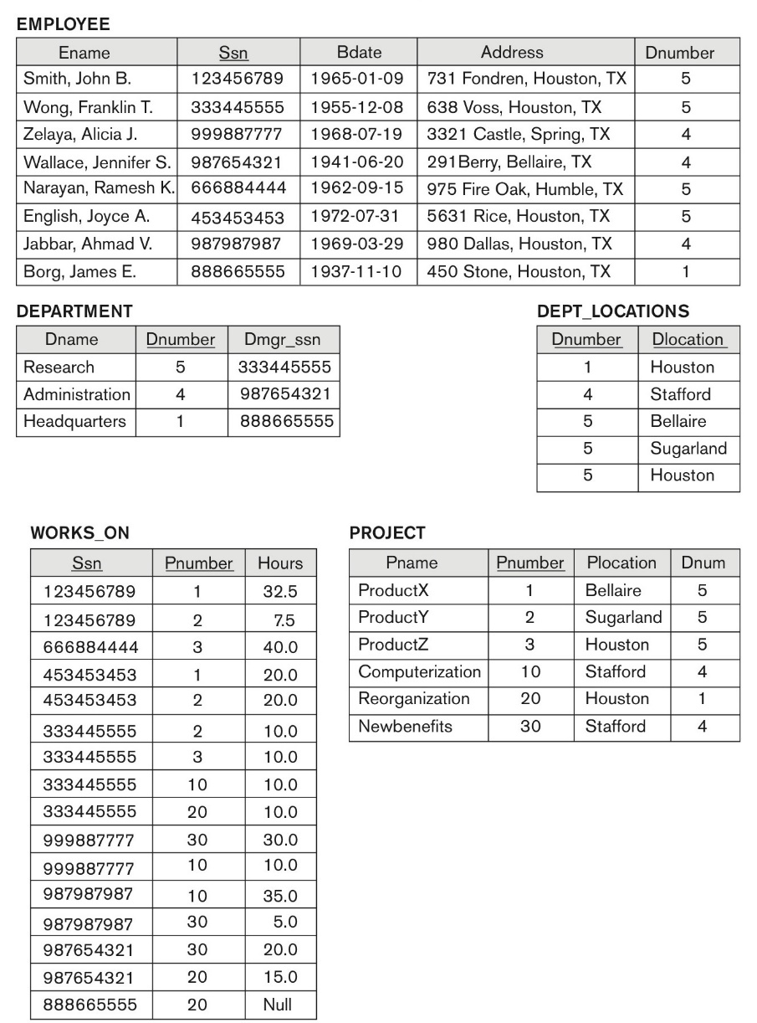
****

Fig 4.1: DEPARTMENT_PROJECT DB schema suffering from update anomalies

***
Fig 4.2: A database state of the DEPARTMENT_PROJECT DATABASE derived from Fig 14.2
DNUMBER PNUMBER DNAME PMGR_SSN PNAME PLOCATION
---------- ---------- --------------- --------- --------------- ---------------
5 3 Research 333445555 ProductZ Houston
5 10 Research 333445555 Computerize Stafford
5 20 Research 333445555 Reorganize Houston
5 30 Research 333445555 Nbenefits Stafford
5 1 Research 333445555 ProductX Bellair
5 2 Research 333445555 ProductY Sugarland
4 3 Administration 987654321 ProductZ Houston
4 10 Administration 987654321 Computerize Stafford
4 20 Administration 987654321 Reorganize Houston
4 30 Administration 987654321 Nbenefits Stafford
4 1 Administration 987654321 ProductX Bellair
4 2 Administration 987654321 ProductY Sugarland
1 3 Headquarters 888665555 ProductZ Houston
1 10 Headquarters 888665555 Computerize Stafford
1 20 Headquarters 888665555 Reorganize Houston
1 30 Headquarters 888665555 Nbenefits Stafford
1 1 Headquarters 888665555 ProductX Bellair
1 2 Headquarters 888665555 ProductY Sugarland

18 rows selected.
Solution: (3 + 3 + 3 + 1 marks)
Modification anomalies:
-If DNumber is changed, all projects belonging to DNumber must have their DNumber value updated.
-If Pmgr_ssn is changed, all projects belonging to Pmgr_ssn must be updated
-If DName is changed, all projects with DName must be updated. For example, if DName: Research is changed to Study, all projects in DNumber: 5 must update their DName values to Study.

Insertion anomalies:
-Cannot insert a department that has no projects. To do this, Pnumber would have to be NULL which is a entity integrity violation.
-To insert a new project, DNumber, DName, and Pmgr_ssn must be consistent with all corresponding values of a department. For example, projects in DNumber: 5 must all have the same DNumber, DName, and Pmgr_ssn. This is a lot of redundant information.

Deletion anomalies:
-If a department were to complete all its projects and have all its project entries removed from the database, the department itself would be lost as it cannot exist without a project. For example, in Fig4.2, all DNumbers are paired with a Pnumber. So if all projects of a department are finished, the entries for the projects are removed from the relation and also the department.

